**Practical No. 6**

PRN: 2019BTECS00081 Name: Prathamesh A. Mehare

Q1: Implement a MPI program to give an example of Deadlock

Output:

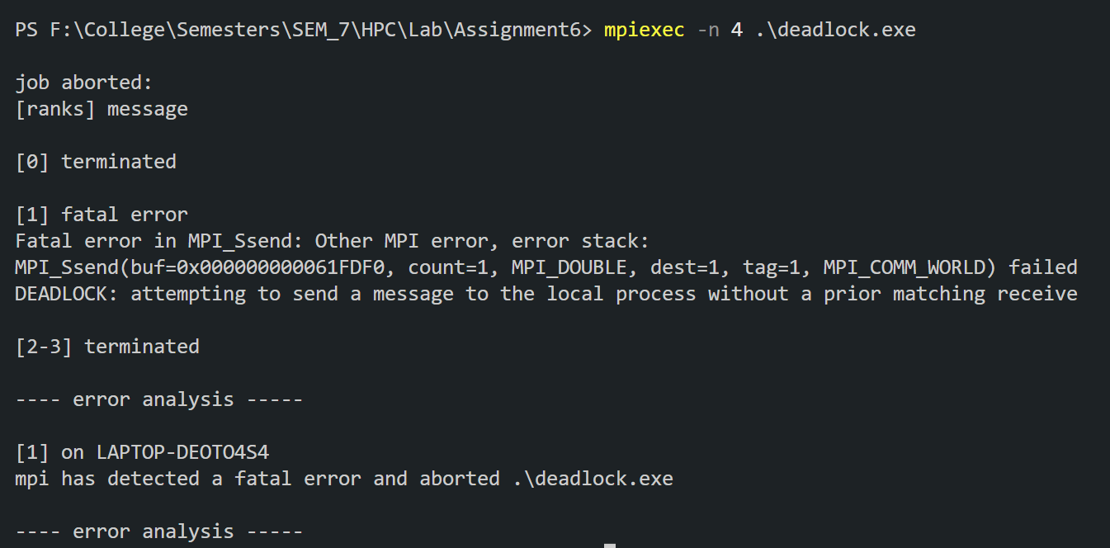

Q2. Implement blocking MPI send & receive to demonstrate Nearest neighbor exchange of data in a ring topology.

Ans:

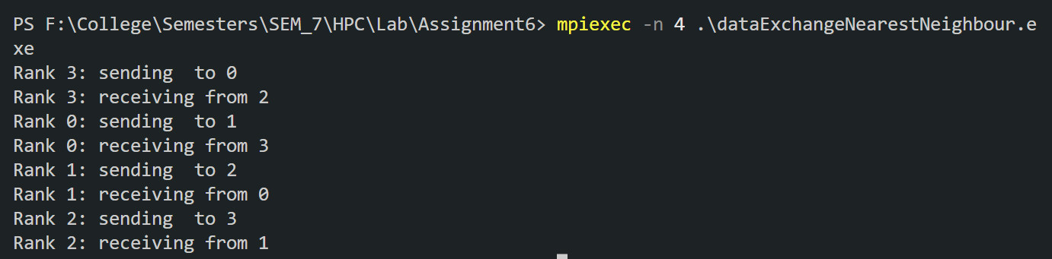

Q3. Write a MPI program to find the sum of all the elements of an array A of size n. Elements of an array can be divided into two equals groups. The first [n/2] elements are added by the first process, P0, and last [n/2] elements the by second process, P1. The two sums then are added to get the final result.

Ans:



GITHUB LINK:

<https://github.com/mystic-one/HPC_Practicals/tree/main/Assignment6>